**SQL FUNDAMENTALS**

**SELECT Statement**

**Introduction**

In this lesson, you will focus on the SELECT statement in SQL. Generally;

* The SELECT statement is used to select data from a database.
* You can retrieve rows from the columns of the table by using this statement.
* SELECT statement is used with FROM keyword.
* The syntax of the SELECT statement can be seen below.

SELECT column_name(s) FROM table_name;

By using this query, you explain to SQL that you want to see the data from a column/columns in the given table. The result of the query is stored in a result table called *result-set*.

**Basic Syntax**

The term syntax in SQL refers to strict structural patterns used when creating a query. As in any other programming language, SQL also has some general syntax rules to follow. But these rules are very flexible compared with others. Let' look at the syntax of the last query again.

SELECT column_name(s) FROM table_name;

As you see, SELECT and FROM words were written in uppercase, and the query ends with a semicolon. Is this usage example a syntax rule? In SQL syntax;

* SQL statements start with a keyword like SELECT, INSERT, UPDATE, DELETE, etc. and all the statements end with a semicolon (;).
* The semicolon at the end indicates that the statement is completed and ready to be executed.
* SQL is also case insensitive, which means you can use both SELECT and select in your query. They mean the same thing for SQL.
* Writing SQL commands in the upper-case is the most common and preferred style. But, you can write the same query in both ways as below:

select column_name(s) from table_name;

SELECT COLUMN_NAME(s) FROM TABLE_NAME;

* White spaces and empty lines are ignored in SQL. So, the below query is correct by all means.

SELECT column_name(s)

FROM table_name;

**💡 Tip:** To maintain your query clean and more readable, it's not recommended to use unnecessary empty lines and white spaces .

**Selecting Multiple Columns**

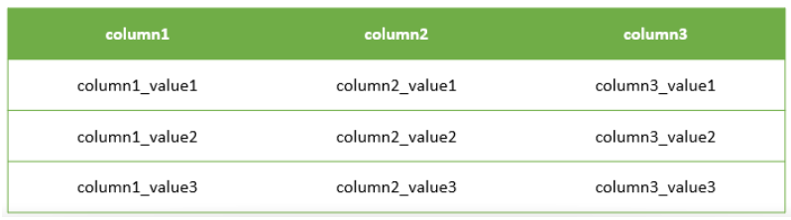

 Assume that;

* You have a table named as **table1** like above.
* You want to see only column1 and column2 data in it.
* Then, you should write a query like this:

query :

SELECT column1, column2 FROM table1;

After you execute this query, SQL will return you only the data that you want from column1 and column2 of table1.  
  
output :

column1 column2

-------------- --------------

column1_value1 column2_value1

column1_value2 column2_value2

column1_value3 column2_value3

**Selecting All Columns**

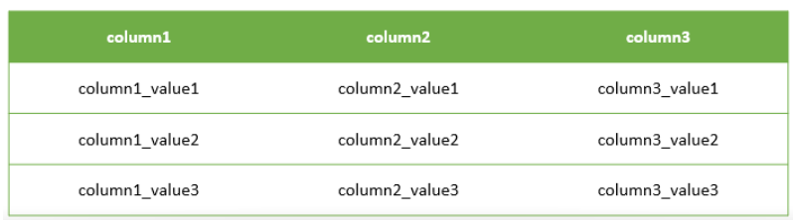

Assume that; this time you want to see all of the data in your table.

You have 3 columns in your table, so you should write a query like this.

query :

SELECT column1, column2, column3 FROM table1;

Because you wrote the names of all the columns in the SELECT statement, you will get the whole table via this query.

output :

column1 column2 column3

-------------- -------------- --------------

column1_value1 column2_value1 column3_value1

column1_value2 column2_value2 column3_value2

column1_value3 column2_value3 column3_value3

* Ok, it's not difficult to write 3 columns in this case, but think about you have a big table with lots of columns.
* Would you have to write all the column names in your query?

**Brainstorming:** Think about a more easy way to use for getting all the data in your table. We'll talk about it in the next step.

### Selecting All Columns (Special Character)

The asterisk character “*” has special meaning in SQL.

To retrieve all of the information from your table, an asterisk (*) character can be used after the SELECT command.

So, you wouldn't have to type in each of the column names separately.

query :

SELECT * FROM table1;

By using **the asterisk character “*”**, you can get every column with all of the data in it as a result-set of the query.

output :

column1 column2 column3

-------------- -------------- --------------

column1_value1 column2_value1 column3_value1

column1_value2 column2_value2 column3_value2

column1_value3 column2_value3 column3_value3